Lab - Configure Single-Area OSPFv2

Topology

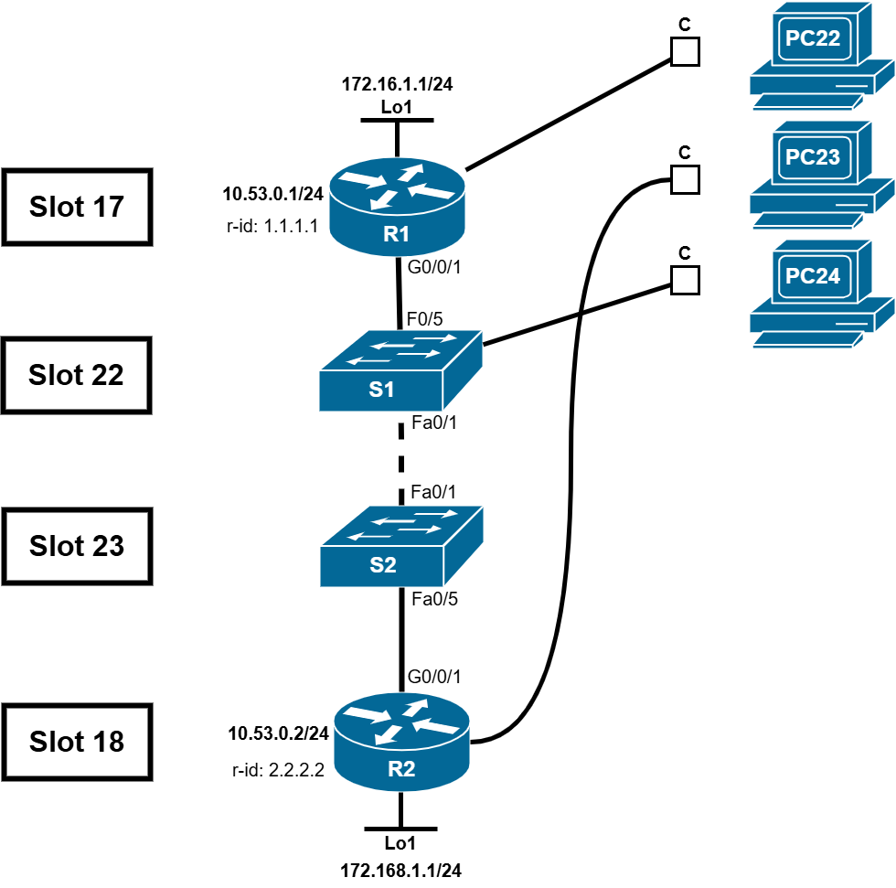

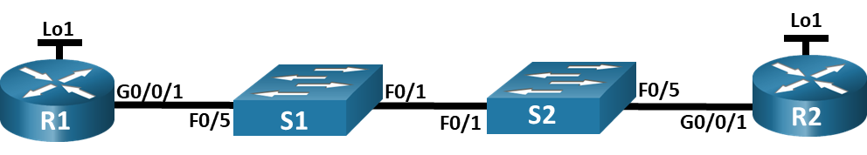

Addressing Table
Device | Interface | IP Address | Subnet Mask
R1 | G0/0/1 | 10.53.0.1 | 255.255.255.0
R1 | Loopback1 | 172.16.1.1 | 255.255.255.0
R2 | G0/0/1 | 10.53.0.2 | 255.255.255.0
R2 | Loopback1 | 192.168.1.1 | 255.255.255.0

Objectives
Part 1: Build the Network and Configure Basic Device Settings
Part 2: Configure and Verify Single-Area OSPFv2 for basic operation
Part 3: Optimize and Verify the Single-Area OSPFv2 configuration

Background / Scenario
You have been tasked with configuring a small company’s network using OSPFv2. R1 will be hosting an internet connection (simulated by interface Loopback 1) and sharing the default route information to R2. After the initial configuration, the organization has asked for the configuration to be optimized to reduce protocol traffic and ensure that R1 remains in control of routing.
Note: The static routing approach used in this lab is to assess your ability to configure and adjust OSPFv2 in a single-area configuration. This approach used in this lab may not reflect networking best practices.
Note: The routers used with CCNA hands-on labs are Cisco 4221 with Cisco IOS XE Release 16.9.4 (universalk9 image). The switches used in the labs are Cisco Catalyst 2960s with Cisco IOS Release 15.2(2) (lanbasek9 image). Other routers, switches, and Cisco IOS versions can be used. Depending on the model and Cisco IOS version, the commands available and the output produced might vary from what is shown in the labs. Refer to the Router Interface Summary Table at the end of the lab for the correct interface identifiers.
Note: Ensure that the routers and switches have been erased and have no startup configurations. If you are unsure contact your instructor.

Required Resources
- 2 Routers (Cisco 4221 with Cisco IOS XE Release 16.9.4 universal image or comparable)
- 2 Switches (Cisco 2960 with Cisco IOS Release 15.2(2) lanbasek9 image or comparable)
- 1 PC (Windows with a terminal emulation program, such as Tera Term)
- Console cables to configure the Cisco IOS devices via the console ports
- Ethernet cables as shown in the topology

Instructions

Build the Network and Configure Basic Device Settings.

Cable the network as shown in the topology.
Attach the devices as shown in the topology diagram, and cable as necessary.

Configure basic settings for each router.
Open configuration window
      - Assign a device name to each router.
      - Disable DNS lookup to prevent the router from attempting to translate incorrectly entered commands as though they were host names.
      - Assign class as the privileged EXEC encrypted password.
      - Assign cisco as the console password and enable login.
      - Assign cisco as the VTY password and enable login.
      - Encrypt the plaintext passwords.
      - Create a banner that warns anyone accessing the device that unauthorized access is prohibited.
      - Save the running configuration to the startup configuration file.

Configure basic settings for each switch.
      - Assign a device name to each switch.
      - Disable DNS lookup to prevent the router from attempting to translate incorrectly entered commands as though they were host names.
      - Assign class as the privileged EXEC encrypted password.
      - Assign cisco as the console password and enable login.
      - Assign cisco as the VTY password and enable login.
      - Encrypt the plaintext passwords.
      - Create a banner that warns anyone accessing the device that unauthorized access is prohibited.
      - Save the running configuration to the startup configuration file.
Close configuration window

Configure and Verify Single-Area OSPFv2 for basic operation.

Configure interface addresses and basic OSPFv2 on each router.
      - Configure interface addresses on each router as shown in the Addressing Table above.
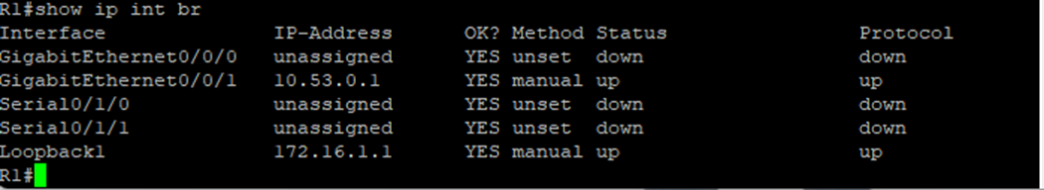
Open configuration window
      - Enter OSPF router configuration mode using process ID 56.
      - Configure a static router ID for each router (1.1.1.1 for R1, 2.2.2.2 for R2).
      - Configure a network statement for the network between R1 and R2 placing it in area 0.
      - On R2 only, add the configuration necessary to advertise the Loopback 1 network into OSPF area 0.
      - Verify OSPFv2 is operational between the routers. Issue the command to verify R1 and R2 have formed an adjacency. (--> Jiran→ show ip ospf neighbor)
R1:
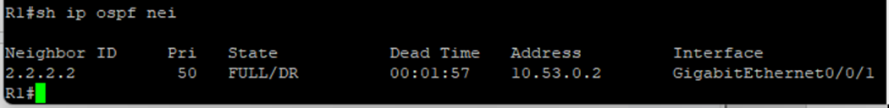
R2:

Question:
Which router is identified as the DR?
- R2 Rid 2.2.2.2
Which is the BDR?
- R1 Rid 1.1.1.1
What was the selection criteria?
- Router ID (highest id win )Type your answers here.
      - On R1, issue the show ip route ospf command to verify that the R2 Loopback1 network is present in the routing table. Notice the default behavior of OSPF is to advertise a loopback interface as a host route using a 32 bit mask.
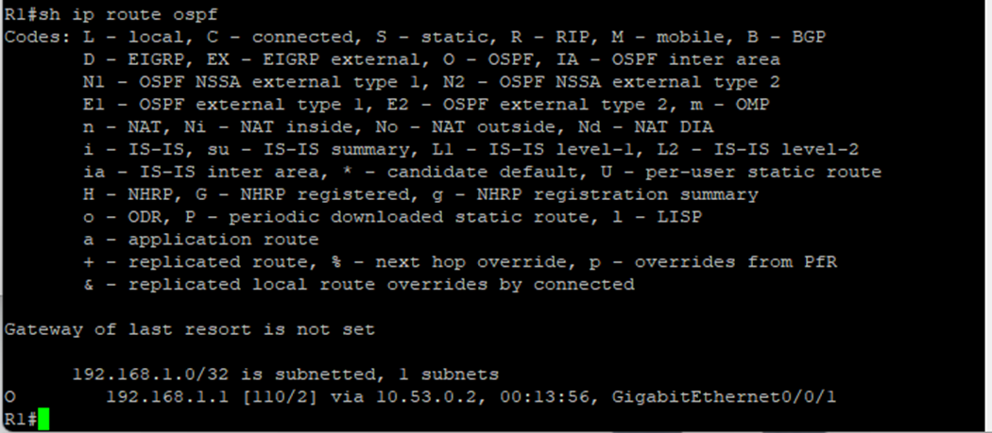
      - Ping the R2 Loopback 1 interface address from R1. The ping should succeed.
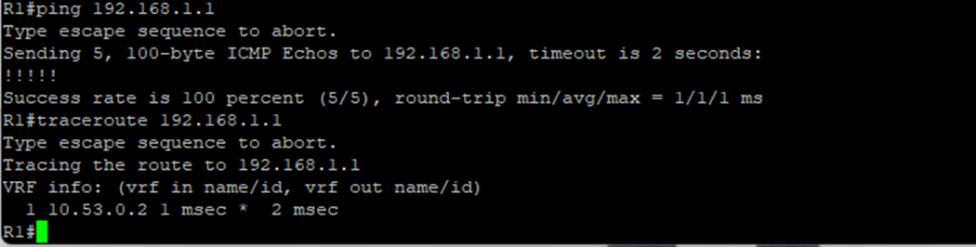
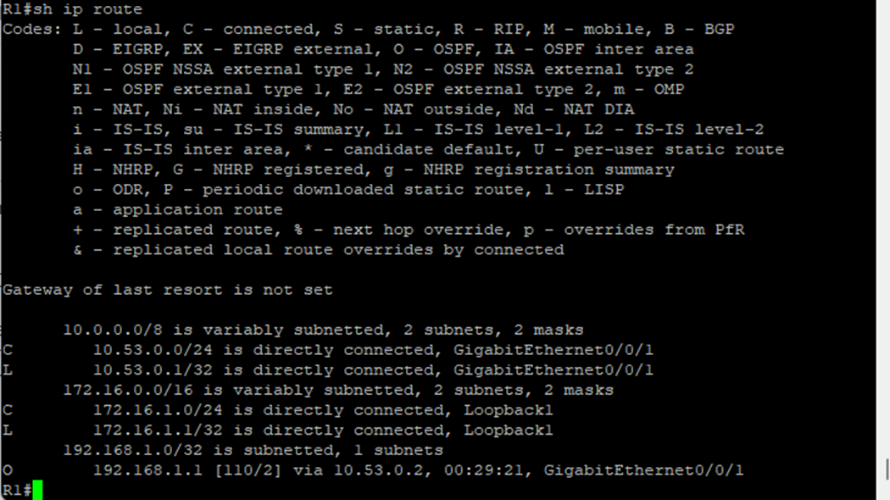
close configuration window

Optimize the Single-Area OSPFv2 configuration

Implement various optimizations on each router.
Open configuration window
      - On R1, configure the interface G0/0/1 OSPF priority to 50 to ensure R1 is the Designated Router.
      - Configure the OSPF timers on the G0/0/1 of each router for a hello timer of 30 seconds.
      - On R1, configure a default static route that uses interface Loopback 1 as the exit interface. Then, propagate the default route into OSPF. Note the console message after setting the default route.
      - On R2 only, add the configuration necessary for OSPF to treat R2 Loopback 1 like a point-to-point network. This results in OSPF advertising Loopback 1 using the interface subnet mask.
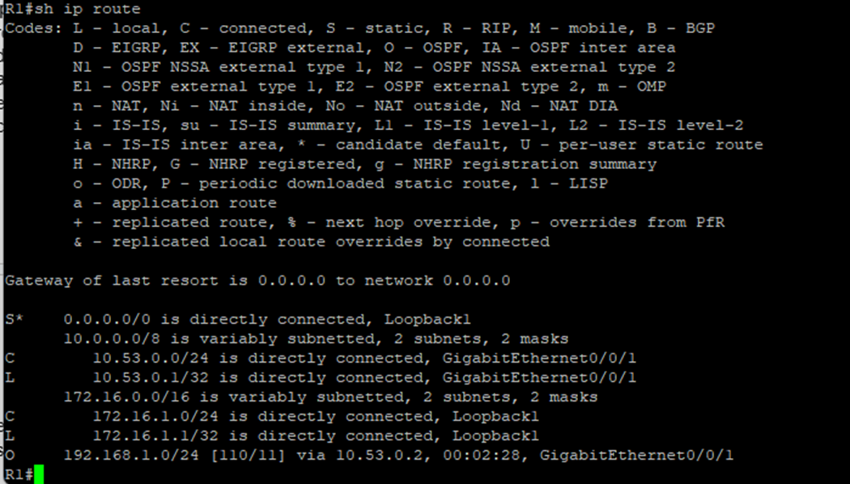
      - On R2 only, add the configuration necessary to prevent OSPF advertisements from being sent to the Loopback 1 network.
      - Change the reference bandwidth on each router to 1Gbs. After this configuration, restart OSPF using the clear ip ospf process command. Note the console message after setting the new reference bandwidth.
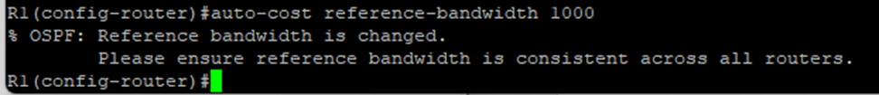
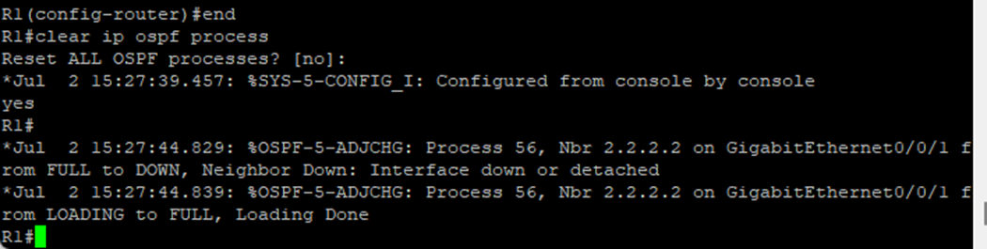

Verify OSPFv2 optimizations are in place.
      - Issue the show ip ospf interface g0/0/1 command on R1 and verify that the interface priority has been set to 50 and that the time intervals are Hello 30, Dead 120, and the default Network Type is Broadcast
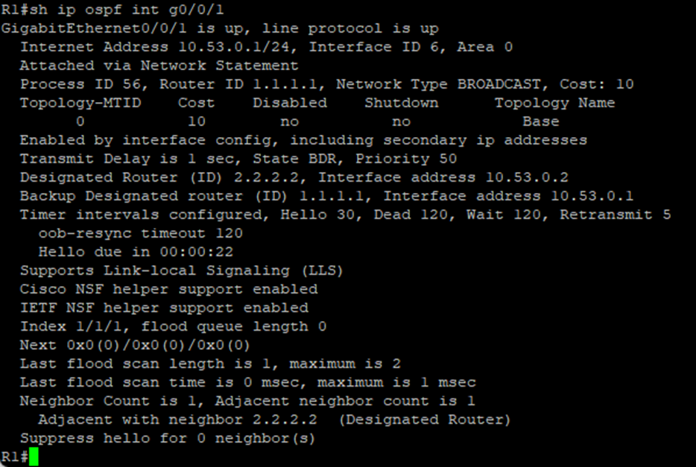
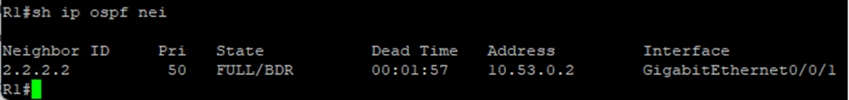
      - On R1, issue the show ip route ospf command to verify that the R2 Loopback1 network is present in the routing table. Note the difference in the metric between this output and the previous output. Also note the mask is now 24 bits as opposed to the 32 bits previously advertised.
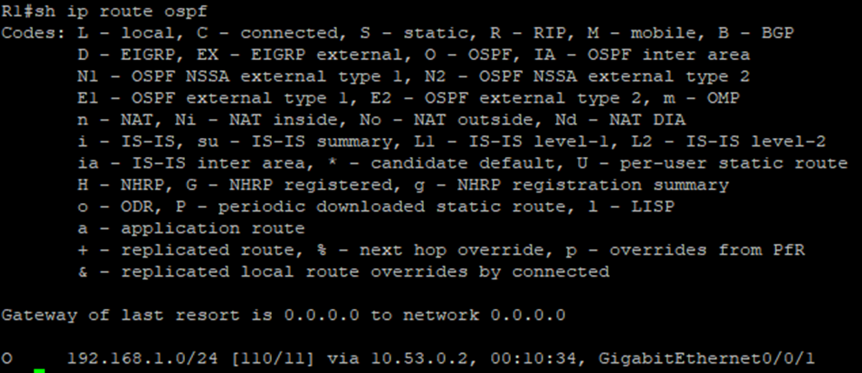
      - On R2, issue the command. The only OSPF route information should be the default route R1 is propagating.
      - Ping the R1 Loopback 1 interface address from R2. The ping should succeed.
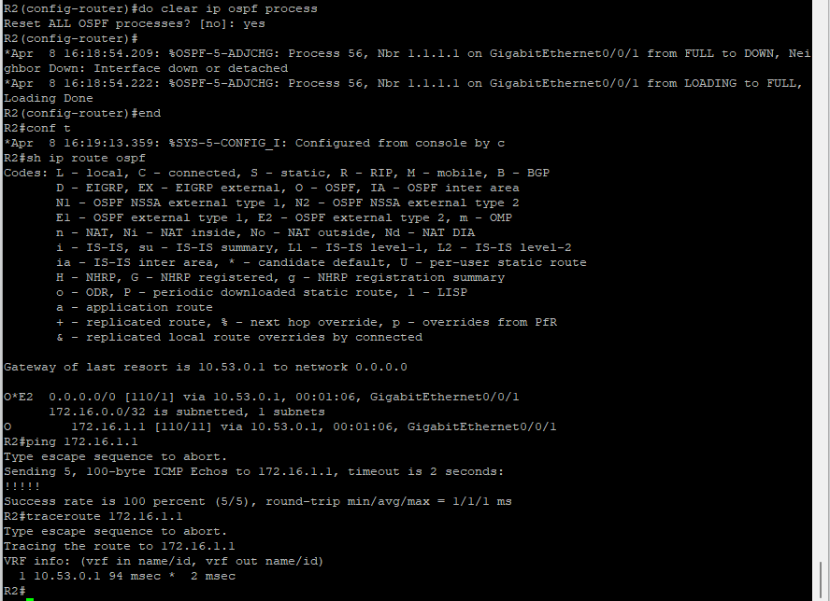

Question:
Why is the OSPF cost for the default route different than the OSPF cost at R1 for the 192.168.1.0/24 network?
Ospf is count cost by cumulative (E1), E2 is default, cost 1 throughout the network
192.168.1.
Type your answers here.
Close configuration window

Router Interface Summary Table
Router Model | Ethernet Interface #1 | Ethernet Interface #2 | Serial Interface #1 | Serial Interface #2
1800 | Fast Ethernet 0/0 (F0/0) | Fast Ethernet 0/1 (F0/1) | Serial 0/0/0 (S0/0/0) | Serial 0/0/1 (S0/0/1)
1900 | Gigabit Ethernet 0/0 (G0/0) | Gigabit Ethernet 0/1 (G0/1) | Serial 0/0/0 (S0/0/0) | Serial 0/0/1 (S0/0/1)
2801 | Fast Ethernet 0/0 (F0/0) | Fast Ethernet 0/1 (F0/1) | Serial 0/1/0 (S0/1/0) | Serial 0/1/1 (S0/1/1)
2811 | Fast Ethernet 0/0 (F0/0) | Fast Ethernet 0/1 (F0/1) | Serial 0/0/0 (S0/0/0) | Serial 0/0/1 (S0/0/1)
2900 | Gigabit Ethernet 0/0 (G0/0) | Gigabit Ethernet 0/1 (G0/1) | Serial 0/0/0 (S0/0/0) | Serial 0/0/1 (S0/0/1)
4221 | Gigabit Ethernet 0/0/0 (G0/0/0) | Gigabit Ethernet 0/0/1 (G0/0/1) | Serial 0/1/0 (S0/1/0) | Serial 0/1/1 (S0/1/1)
4300 | Gigabit Ethernet 0/0/0 (G0/0/0) | Gigabit Ethernet 0/0/1 (G0/0/1) | Serial 0/1/0 (S0/1/0) | Serial 0/1/1 (S0/1/1)
Note: To find out how the router is configured, look at the interfaces to identify the type of router and how many interfaces the router has. There is no way to effectively list all the combinations of configurations for each router class. This table includes identifiers for the possible combinations of Ethernet and Serial interfaces in the device. The table does not include any other type of interface, even though a specific router may contain one. An example of this might be an ISDN BRI interface. The string in parenthesis is the legal abbreviation that can be used in Cisco IOS commands to represent the interface.

R1
en
conf t
hostname R1
no ip domain lookup
line console 0
logging synchronous
end

int g0/0/1
ip add 10.53.0.1 255.255.255.0
no shut
int Loopback1
ip add 172.16.1.1 255.255.255.0
no shut

router ospf 56
router-id 1.1.1.1
network 10.53.0.0 0.0.0.255 area 0
network 172.16.1.0 0.0.0.255 area 0

end
sh ip ospf nei

sh ip route ospf

ping 192.168.1.1
traceroute 192.168.1.1

conf t
int g0/0/1
ip ospf 56 area 0
ip ospf priority 50
ip ospf hello-interval 30
ip ospf dead-interval 120

exit
ip route 0.0.0.0 0.0.0.0 Loopback1
router ospf 56
default-information originate
auto-cost reference-bandwidth 1000
end
clear ip ospf process

end
sh ip ospf int g0/0/1

R2
en
conf t
hostname R2
no ip domain-lookup
logging synchronous
end

int g0/0/1
ip add 10.53.0.2 255.255.255.0
no shut
int Loopback1
ip add 192.168.1.1 255.255.255.0
no shut
exit
int Loopback1
ip ospf 56 area 0

router ospf 56
router-id 2.2.2.2
network 10.53.0.0 0.0.0.255 area 0
network 192.168.1.0 0.0.0.255 area 0

end
sh ip ospf nei

sh ip route ospf

conf t
int Loopback 1
ip ospf 56 area 0

int g0/0/1
ip ospf hello-interval 30

int loopback 1
ip ospf network point-to-point

exit
router ospf 56
passive-interface Loopback1
auto-cost reference-bandwidth 1000
clear ip ospf process

end
sh ip route ospf
ping 172.16.1.1
traceroute 172.16.1.1

S1
en
conf t
hostname S1
no ip domain-lookup

S2
en
conf t
hostname S2
no ip domain-lookup

End of document

